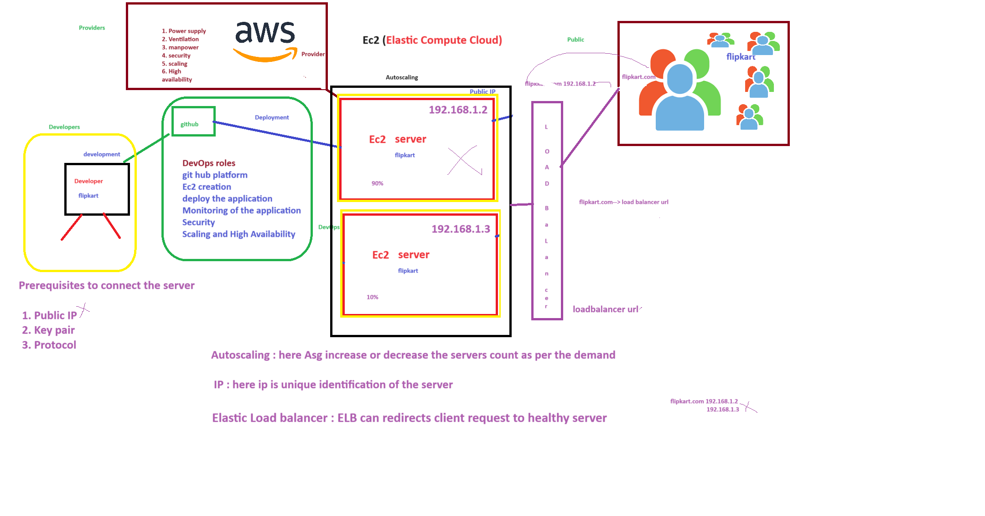 load balancer: balance the load.

In AWS load balancer as Elastic Load Balancer(ELB).